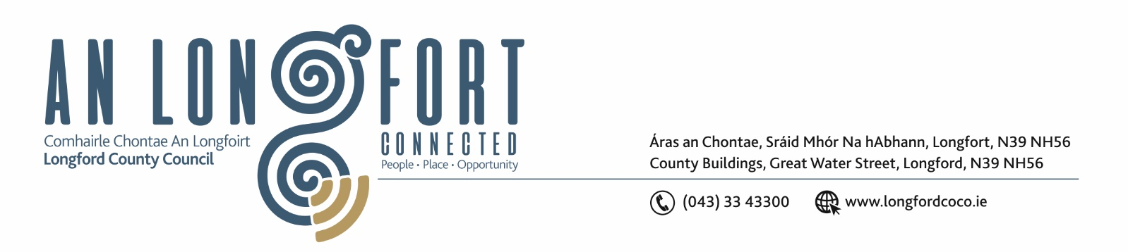

25th February 2020.

To: Each Member of the Joint Policing Committee.

Re: Meeting of the Joint Policing Committee

Dear Member,

I wish to inform you that the next meeting of the Joint Policing Committee will take place in the Council Chamber, Aras an Chontae, Great Water Street, Longford, on Monday, 2nd March 2020 at
3.00 p.m.

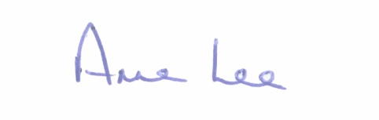
Yours sincerely,

___________________
Anne Lee,
Administrative Officer.

AGENDA

Apologies received.

1. Confirmation of Minutes of Joint Policing Committee meeting held on the
2nd December 2019 - enclosed.

2. Matters arising.

3. Declaration of Interest by Members.
4. Garda Report.

5. Local Authority Report.

6. Consideration of Longford Joint Policing Committee 2019 Annual Report – enclosed.

7. Update on Longford Joint Action Plan.

8. Date of next meeting.

